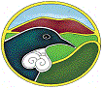Waikato Biodiversity Forum Newsletter September 2006 Number 13

Kia Ora/Greetings to all Forum Members
Hope you are all well and enjoying spring and a noticeable warming of the sun and the air. Daylight saving begins this weekend so the evenings will appear longer. Spring has sprung.

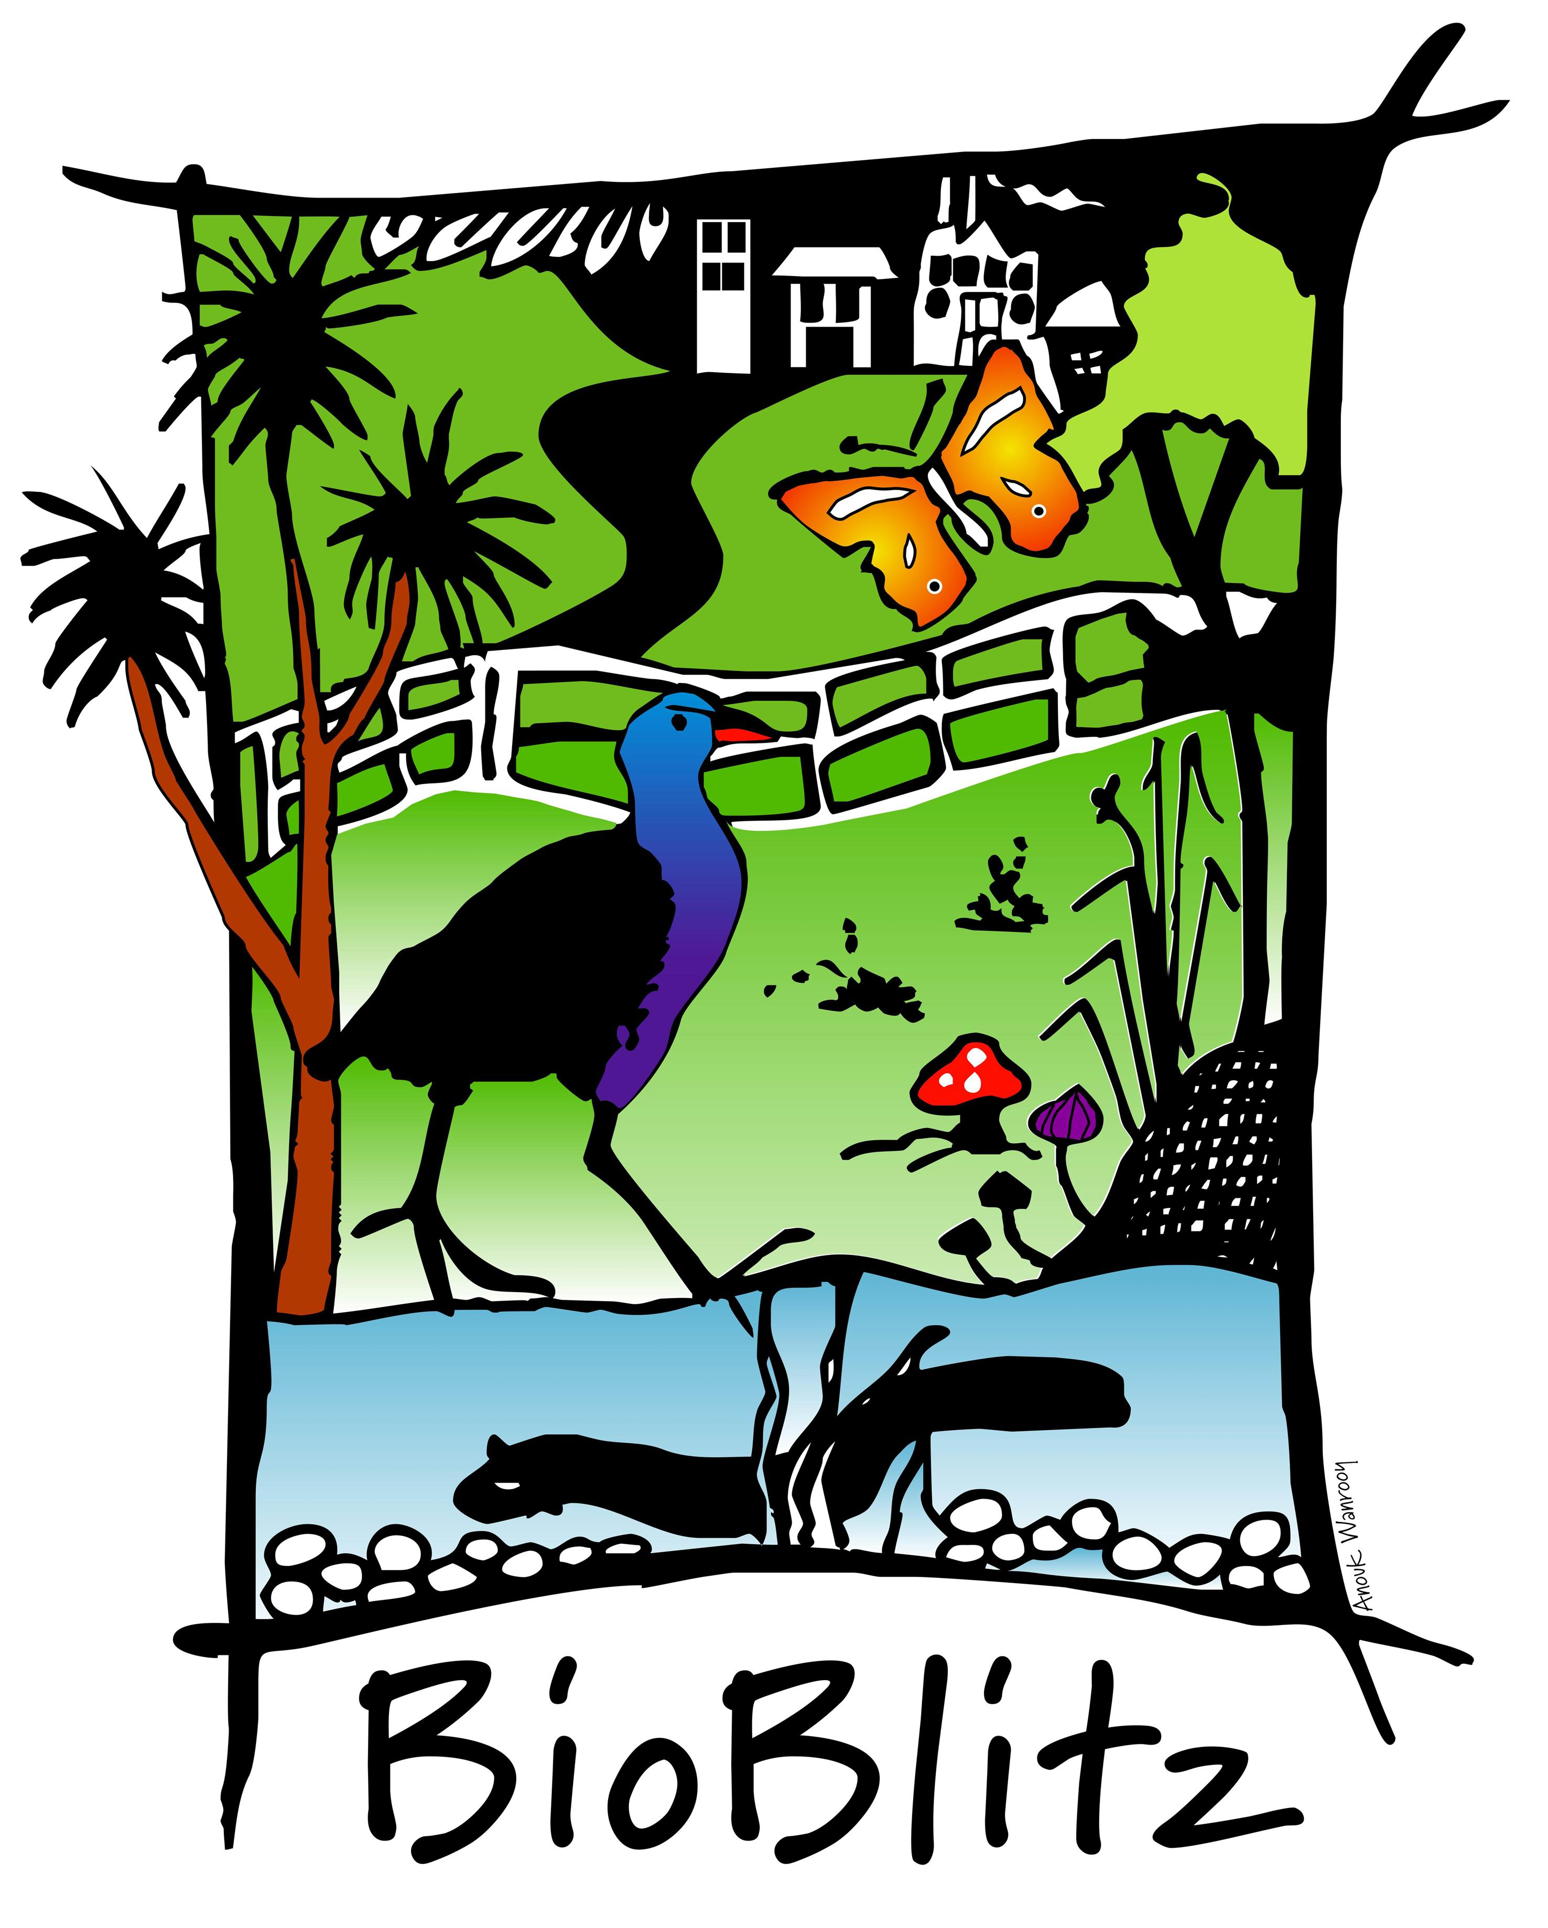
Next Waikato Biodiversity Forum

BioBlitz in Hamilton City

Date: 10-11 November 2006
Time: Friday 10 November 12 midday -12 midnight
Saturday 11 November 6am- 2pm
Base Camp: Museum
Zones: Parana Park,
Waikato River and the bank between the Claudelands and Victoria Street
Bridges.

You are all invited to attend any time during those hours detailed above. This is your formal invitation. There is no registration and the event is open to the public. If any of you would like to be involved or help in any way please be in touch.

What is a BioBlitz?
BioBlitz is an international brand name for an event that is part contest, part festival, part educational event, part scientific endeavor, and brings together scientists from Research Institutions and other organisations from across the region in a race against time to identify as many species as possible in a 24-hour biological survey of a particular location. New information on the distribution and occurrence of flora and fauna is generated, and associated outreach activities raise public awareness of biodiversity and its relevance to everyday life. The first New Zealand BioBlitz was coordinated by Landcare Research in Auckland in 2004, and this will be the fifth event of its kind in New Zealand.

The "base camp" is the hub of the BioBlitz. It is a centralised venue equipped with microscopes, computers, species tally board and other equipment. This is where identifications take place, discoveries are made, and the tally of species is recorded. Supplementary activities, such as demonstrations, relevant exhibits, make-and-take projects and guest speakers are also carried out here. The public is invited to observe the scientists’ activities, to interact with them, and to participate in other activities that are presented by the organisers and a host of invited nature-oriented organizations. The event includes opening speeches and a closing ceremony where the final tally is announced.

The coordination of this event is being done by the Waikato Biodiversity Forum, supported by the organising committee comprising representatives from Landcare Research, NIWA, NZ Landcare Trust, University of Waikato, Department of Conservation, Hamilton City Council and Environment Waikato. See http://www.waikatobiodiversity.org.nz/81/ for details.

Conserv-Vision Conference 4 -7 July at the University of Waikato
The goals of the conference are to bring together practitioners, scientists, policy-makers and conservation advocates from New Zealand and elsewhere to: consider future challenges for conservation agencies and how existing models might be strengthened or adapted to meet them; review and evaluate the achievements of the past 20 years of conservation management in New Zealand; and assess the way in which conservation agencies might best achieve their goals for conservation outcomes in 2050 and beyond. The Waikato Biodiversity Forum plans to be involved in organizing a field trip to view the work of community groups in a few areas of the region so you may be asked if you want to be involved. . See http://www.waikato.ac.nz/wfass/Conserv-Vision/ for details.

District Councils and the Waikato Biodiversity Forum
The Waikato Biodiversity Forum made submissions to all District Councils through the LTCCP process for funding to assist with the operation of the Forum. The following Councils agreed to contribute funding to the Forum. Thames Coromandel District Council, Waipa District Council, Hamilton City Council, Rotorua District Council, Waitomo District Council, Hauraki District Council, Waikato District Council, South Waikato District Council, Taupo District Council and Matamata Piako District Council. The Forum would like to thank the Councils for their contribution and will work with Councils to achieve biodiversity outcomes.

Focus Group (Management Group of the Forum) and Project Teams
The Forum Focus group is now meeting 2 monthly from 4-6pm at Landcare Research. The dates for the rest of the years meetings are 8 November for a general meeting and 6 December for the last meeting of the year and a Xmas get together. You are most welcome to attend the Focus Group meetings. The agenda for each meeting is available from Moira. The Focus group has moved to operate under project teams and in the future may invite members of the Forum who haven’t been on the Focus Group to work in a project team with specific focus for a defined period of time. This is already happening with the BioBlitz event planning. We have just formed a project team for the promotion of the Restoring Waikato’s Indigenous Biodiversity: Ecological Priorities and Opportunities document.
District Councils have been invited to send a representative to each Focus group meeting and some Councils have taken up this invite.

Biodiversity Advice Waikato 0800BIODIV (246348)
Biodiversity Advice Waikato (BAW) – 0800246 348 – The WBF Forum free phone line.
One of the services offered by Biodiversity Advice Waikato is to encourage the planting of appropriate native plants.
During the winter of 2006 the BAW Key Contact has been involved with the planting of over 3,000 native plants in the Waikato region. This number does not include Factsheets or lists of recommended native plants that were posted to enquirers.
This has been by way of purchasing; delivering the plants to the site; sourcing; obtaining funding for plant purchasing; organizing planting by community groups or placement of the trees and shrubs on site.
This has been a very satisfying achievement, and adding to the enjoyment is an awareness of the indigenous invertebrates and birds that will gain from the availability of their native foods in the future.
Jan Hoverd
Biodiversity Advice Waikato
Ph 0800246 348 (0800BIODIV)
Email biodiv@bioforum.org.nz

Project Hahei
Project Hahei has now been going about eight years. Intially it helped DoC with possum control in the Cathedral Cove and Te Pari Reserves by baiting the traps every month. Then with the no broadificoum policy we couldn't see all the good work undone so with help from Project Crimson, Forest & Bird, and private donations traps were purchased for mustelids, possums, cats, and rats. These were baited and checked three times a week at that stage but now we are down to once a week as pest numbers are well down.
With more time on our hands (yeah right!) we branched out onto weeds with woolly nightshade being NO 1. Since then we have moved onto, moth plant, wattle, and blackberry. The whole area looks so much better with native seedlings coming up everywhere and prolific bird life. We are also growing and planting trees that have just about disappeared in the reserve such as kohekohe, and nikau.
Here are some of the catch figures for this year; 15 possums, 11 stoats (way up this year as only had 2 last year) 4 weasels, 1 cat, 66 rats, 55 mice, 10 hedgehogs. I also have the figures for previous years and most are showing a decline. Possums depends on numbers coming into the reserve from the surrounding area.
Phil Costello

Forum and Biodiversity Advice Waikato Website
Check out the website www.waikatobiodiversity.org.nz. I welcome any feedback on the site to make improvements. The newsletters are all placed on the website for easy access although I will still be sending them to you by email and post.

Contact the Forum Coordinator through Biodiversity Advice Waikato 0800 BIODIV ( 246348)

