________________________________________________________________
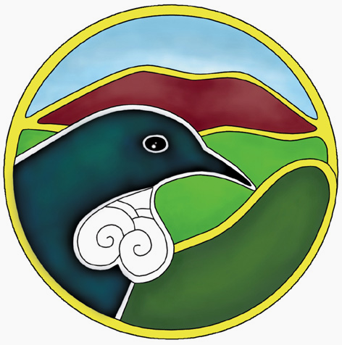
Waikato Biodiversity Forum
_________________________________________________________

Newsletter Number 3, July 2003

The Waikato Biodiversity Forum Meeting

The Waikato Biodiversity Forum met on Thursday 26 June 2003 at the Hamilton Gardens. As it is the International Year of Freshwater the forum provided an opportunity for Forum members to focus on Biodiversity and Freshwater. Presentations included a “vision” based on the relationship that Tainui have with their Te Tupuna, Awa, the Waikato River and the tributaries, flora, fauna and whenua that contribute to its overall well-being, a scientists view of stream ecology and the importance of clean water to the life that inhabits streams and rivers and the challenges and successes of farming in a wetlands area.

A big thank you to the speakers who presented such stimulating information.

The following organizations reported on their activities:
Dexcel, Sally Millar highlighted the establishment of a demonstration site for riparian management on dairy farms.

Whenuakite Kiwi Care Group, Arthur Hinds spoke about the pest control work on 3oooha of land at Whenuakite to provide a safer habitat for kiwi.

Tui 2000, Suli Tuvuki highlighted the planting and pest control work being carried out at Barretts Bush west of Hamilton.

Advisory Committee for Regional Environment (ACRE), Catherine Smith spoke about the advisory and advocacy work this Committee does on behalf of approximately 30 environmental groups. The Committee plays an advocacy and advisory role for Environment Waikato.

Hakarimata Restoration Trust and the Lower Waikato River Enhancement Society, Wayne Bennett described the numerous planting projects undertaken by these groups.

Landcare Research, Daniel Rutledge introduced a recent publication entitled “Land Environment of New Zealand”. Copies of this book were donated to the Forum and are available at the Hamilton Environment Centre Library. The book provides information on effective ways to manage our environment in a sustainable manner.

Maungatautari Ecological Island Trust, Jillana Robertson spoke about the Trust’s aim to build a 47 km predator free fence around the Maungatautari Mountain and reintroduce “lost species”
Forum participants took part in a field trip in the afternoon visiting a gully restoration area north of Hamilton City, the wastewater treatment facility at the back of the New Zealand Milk Products factory in Te Rapa and Lake Rotokauri. These visits gave participants an opportunity to see first hand how local organisations are improving the biodiversity of wetland areas and the Waikato River. Finally there was a viewing of Horseshoe (Waiwhakareke) Lake where there is a plan to recreate a peat wetland for a natural heritage park.

The Forum was videoed thanks to Action Bio-Community and I have 5 CDs of the Forum for you to borrow. Please contact me to loan the CDs.

Julian Williams presentation is available from me electronically or as a paper copy and Kevin Collier s presentation is available on CD for loan.

The feedback from the Forum is also available from Moira. See email and phone number below.
Thank you to everyone who contributed to making the Forum meeting a success.

The New Zealand Ecological Restoration Network (NZERN) website www.bush.org.nz
is being built to be a site of useful information on ecological restoration. Some of you would have met Mike Peters at the last Forum meeting. He would like to put information on agencies and community groups on their website and has asked me to supply names of groups and contacts. I am however reluctant to do this until I have your permission. Ph 07 839 2460 if you do not want me to pass on details of your group to NZERN. If you pay a $10 fee to NZERN you can have access to all sections of the website.

Forum Co-ordinator Contact
Moira Cursey Ph 07 839 2460
Email moira.cursey@bioforum.org.nz

Two Stories of Biodiversity Related Activities From the Region

Lower Waikato River Enhancement Society Inc (LWRES) uses a co-operative approach to planting natives on the banks of the Lower Waikato River for habitat restoration. This approach has proven successful with a wide range of organisations, groups and individuals contributing time, expertise and resources to the project.
LWRES have been active on the river since 1999. Key work areas include:-
- Meremere: This site consists of 1km of fencing with a backwater wetland feature on land administered by both DoC and Environment Waikato. Now into its third planting season the site was fenced and planted with 7000 natives in 1999. A further 400 secondary plants have been planted in the 2002 season.
- Horahora: This site was predominantly chosen for its wetland areas associated with old borrow pits. These have been enhanced by the construction of a channel to the river, allowing for fish passage and water fluctuations. Environment Waikato owns the land, of which 2km was fenced and established with 7000 native plants in 2000. A further 6500 plants have been planted in 2002.
- Ngaruawahia: At this site the planting of a good variety of eco-sourced natives was initiated and undertaken by Wayne Bennett and local volunteers on a 300m long strip between the River and Hakarimata Road.
- Rangiriri: This site is located across SH1 from Rangiriri, down Churchill East Road on Environment Waikato land. Well linked to the nearby Te Araroa Walkway, in 2002 the site has been fenced and planted with 6000 plants.
- Huntly: Planting on the riverbank adjacent to Huntly College, with 6,000 plants planted in the 2002 season. This activity has been undertaken as a volunteer community initiative.

Whenuakite Kiwi Care Group (WKCG)
The WKCG is a keen bunch of landowners, locals and agencies, pooling ideas and energy on ways to control Kiwi predators and forest munchers on an area of land on the east coast of the Coromandel Peninsula. The groups aims to meet it’s mission of promoting the welfare of kiwi and their habitat in the Whenuakite and neighbouring areas by forming partnerships, monitoring kiwi, lowering predator numbers, ensuring safe operations, promoting kiwi friendly behaviour and monitoring legislation that could adversely affect kiwi.

In the year 2000 a survey to determine the presence of kiwi, their gender and approximate numbers was carried out by volunteers. An estimated 19 kiwis were discovered and predator control began in a “core area” in which the most kiwis were located. The kiwi monitoring in 2001 found 31 kiwis and the area of population had increased to the adjoining lands of the “core area”. Predator and browser control continued throughout 2002 with about 300 Fenn traps set throughout the protected area. During the 2002 year publicity and education was carried out through the media. T-shirts were chosen as a publicity tool as well as possum fur kiwi and key-ring kiwi, which were bought and sold-on as fund raising items. The year 2003 to date has seen the continuation of predator and browser control and on-going publicity and education.

Shared Vision
The Forum Focus group is meeting on 23 July 2003 at the Tainui Management Offices at Hopuhopu to progress the Shared Vision. It is planned that the draft Shared Vision will be presented at the next Forum meeting for debate and discussion.
Information on the activities of approximately 80 groups has been collected as part of
Habitat Restoration and Reconstruction Strategy and I’m still working on this project. This information will give us all a picture of what is happening now and help develop a basis for planning for the future.

