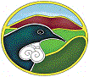 Waikato Biodiversity Forum Newsletter August 2007 Number 16

Kia Ora/Greetings to all Forum Members
Hope all is well in your world as the end of winter approaches and the days get lighter for longer. Spring has nearly sprung with blossoms and daffodils flowering. Enjoy spring and the new growth that it brings.

Restoring Waikato's Indigenous Biodiversity: Ecological Priorities and Opportunities
This document is published and available on the Forum's website. http://www.waikatobiodiversity.org.nz/biodiversity_information/
If you would like a hard copy please phone 0800 BIODIV. We are available to present the information in the document to District Councils and community groups around the region over the coming year. If you have any gatherings of agencies and groups it could be an opportunity for me to attend and talk about the publication.

New Publication
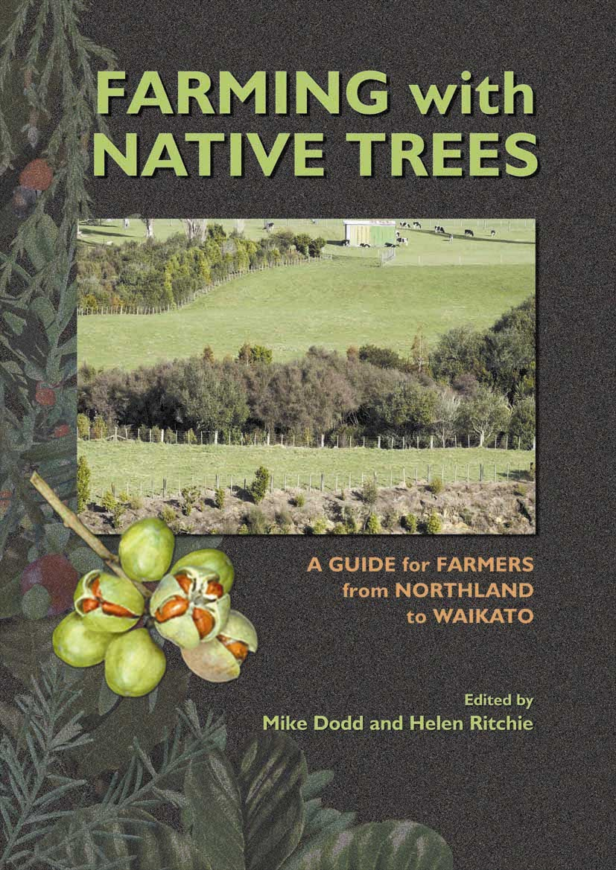

Copies are available from either:
Ian Barton, Tanes Tree Trust, Private Bag 1169, Pukekohe, ph 09 2392049, email ibtrees@wc.net.nz
Publications Officer, Scion, Private Bag 3020, Rotorua, ph 07 3435899, email publications@scionresearch.com
Cost $15+P&P.

There should also be a promotional copy (10pp, ~1Mb) on the following websites soon:
www.tanestrees.org.nz/pubs.php
http://www.maf.govt.nz/sff/about-projects/index.htm

Local Government Elections
If you are attending any "meet the candidate meetings" or trying to suss out candidates views and commitment to biodiversity protection I have some questions you may like to ask candidates in relation to biodiversity management. This is so important. We want biodiversity protection and improvement to be on the radar during these elections.

1. What ideas have you got to improve the plans and policies of the Council to increase the protection and enhancement of biodiversity across the region?

2. What actions would you take as a Councillor to protect and improve biodiversity across the region?

3. What do you think are the most pressing biodiversity issues across the region?

4. If you had to cut costs what would you remove from EWs LTCCP re Biodiversity, Biosecurity and the Natural Heritage Partnership Programme? Or other Councils LTCCPs in relation to biodiversity protection.

Natural Heritage Partnership Programme
Environment Waikato administers a Natural Heritage Partnership Programme. This Programme offers 2 kinds of assistance
- Money from a contestable fund drawn on the targeted rate revenue which amounts to around $800,000 of funding per annum
- Resources such as technical support, staff expertise, political advocacy that are paid for from other funding sources

The purpose of this Fund is to facilitate the permanent preservation, enhancement and public enjoyment of values associated with significant natural features in the Waikato Region.
The issues that EW are trying to addressed by the use of this fund are:
- The subdivision of significant natural coastal landscapes
- The destruction of native habitat
- The loss of public access
- The degradation of existing public lands
- Threats to other significant natural features (wetlands, geothermal, cave etc)

I would like to highlight the existence of this fund and encourage Forum members to be on the look out in their districts and areas for a piece of land that might fit the criteria to be purchased for permanent protection under this fund. This land would need to have significant natural features/ areas of high biodiversity value. A guide could be "Is it one of the 8 major ecosystems of the Waikato as identified in the Forum's publication "Restoring Waikato's Indigenous Biodiversity: Ecological Priorities and Opportunities".
If there was some land for sale or coming up for sale that you feel could fit the criteria for this Programme let me know. The Forum would like to be active in assisting with the process of accessing funding from the Natural Heritage Partnership Programme.

Biodiversity Contestable Advice and Condition Fund.
It would be great if more Waikato region community groups working on private land, private land owners and Local and Regional government could apply and win some of this Condition funding. We have been down over the past couple of years on a slice of the funds in comparison to some other regions. I have the website link below for information about the fund which DOC intends to be open again in September 2007 for applications. I am happy to help you with the filling out the form if you think maybe you qualify for funding through this source. Jan Hoverd from BAW is also available to assist with this.

Scope of the Fund
The Condition Fund is directed at maintenance, restoration and improvement projects designed to protect and enhance indigenous vegetation, species and habitats located outside of reserves and lands managed by the Department of Conservation and local authorities (including wetlands, rivers and other water bodies). These projects could involve, for example, fencing, pest control or forest restoration.
Eligible applicants include:
• Private land owners and managers;
• Local and regional government;
• Professional and community based organisations working on protecting and managing indigenous biodiversity;
• Local, regional and national umbrella groups.
http://www.biodiversity.govt.nz/land/nzbs/pvtland/conditionapps.html

Forest and Bird (Thames/Hauraki)

Waihou River Enrichment Project
For three years now the Thames /Hauraki branch has been working on an environmental enrichment plan for the west bank of the Waihou river. The riparian strip between the river & the bund, which separates rural Haurakii, from a salt meadow and the river, has been the focus of a group of Forest & Birders ,led by Project Manager Ken Clark. The area from the Mangrove margin of the river, which leads into a broad salt meadow, has been the target for enhancement. Clumps of Salt Marsh Ribbonwood Plagianthus divaricatus , Marsh Clubrush Bolboschoenus fluviatilis plus some sprawling Muehlenbeckia complexa, are the only natural colonizers of this area. However the predominant plant is the introduced tall fescue Festuca arundinacea, and it is this zone, both north and south of the Kopu bridge that has been the focus of work.

A considerable amount of experimental planting has taken place over the years, with twenty plus different species of trees and shrubs planted out, both on the West bank and on the eastern side at Shelly Beach. The Southern ,West side strip has been the most successful .This is possibly due to it being the least saline of the areas, in what is a harsh environment , subject to tidal change and salinity.

To date the best results have been achieved with Ngaio Myoporum laetum , Flax Phormium tenax, and Pohutukawa Metrosideros excelsa. Kahikatea Dacrycarpus dacrydioides and Puriri Vitex lucens , have given good but variable results. Most of the other species have failed.
Over the past three years over 740 working hours have been put in. This year over 600 plants have been planted and there are more to go, as the local nursery is growing on another lot of seedlings to a suitable size. The timing for the completion of this project is fortuitous, as this year should also see the completion of the Hydrology studies for the Ecological Rehabilitation of the Kauaeranga Valley Floodplain. This major project, at the entrance into Thames township is a combined DoC , EW ,TCDC and Forest and Bird initiative. Hopefully, planting will start in 2008, after all earthworks and walkways have been completed.

Hakarimata Restoration Trust
The Hakarimata Restoration Trust was established in 2001 to oversee and raise funds for the restoration of approximately 2000ha of private and public conservation land, which includes the 1810ha Hakarimata Scenic Reserve.

The Hakarimata Ranges is the largest remaining lowland forest in the Waikato. At this latitude several species have their northern and southern distibutional limits, particularly those species associated with kauri forest from the north, such as hard beech (Nothofagus truncata), presenting some unique and ecologically significant species assemblages.

Hakarimata is also a stronghold for several species of nationally and regionally threatened plants and animals, including the rare, fragrant native plant Alseuosmia quercifolia or toropapa. Its streams have a rich diversity of fish species including some of New Zealands's rarest native fish. A rich diversity of landsnails has been recorded-122 species.

The Trust has prepared a 10 year management plan providing for ongoing predator control (possums, rodents, goats and weeds), science and research aspects (survey and monitoring, opportunities for student projects), public awareness (education and community participation) and the reintroduction of native birds such as kokako.

Possum and goat control have been undertaken and a number of vegetation plots set up to monitor changes in vegetation. Rodent control is currently being planned. Threatened flora and fauna surveys have been completed. The Trust is also active in promoting recreation opportunities and has assisted in track upgrades. Waikato District Council and Department of Conservation have major plans afoot to upgrade and extend the track network -watch this space.

The Trust is investigating opportunities for public participation in such activities as bird, flora and animal pest monitoring.

For information about these projects phone Biodiversity Advice Waikato 0800 BIODIV

Biodiversity Advice Waikato (BAW) Report
Key Contact , Jan Hoverd Ph.0800BIODIV (0800 246348)
Service operates Monday to Friday, and has an after hours phone.

Email: biodiv@bioforum.org.nz

Autumn and early winter was a busy time for native tree planting in gardens, and farms. BAW was occupied placing shrubs and supporting purchase decisions of the appropriate native plants to buy. Public awareness of the value of native plants continue to grow and it is exciting observing people taking a second look at their areas of broadleaf natives such as Melicytus ramiflorus (mahoe) and Aristotelia serrata (Wineberry).

End of winter brings a change in emphasis to pest management as community groups and individuals prepare for the invasion of pest mammals and how they will combat this problem. Queries include funding sources for the particular project.

Final Update on Release of Karearea (New Zealand Falcon) on Kakepuku Mountain

The captive bred juvenile falcons which were released from the hack box have not received supplementary feeding since the end of June. All three have survived the winter which is the danger time for falcons in their first year. They have been observed feeding on starling, mice and sparrows. Falcon, banded White, spends her time clearing sparrows out of cowsheds and the local farmers love her! Jan Hoverd

Website www.waikatobiodiversity.org.nz. The newsletters are all placed on the website for easy access.

The Forum coordinator can be contacted through Biodiversity Advice Waikato on 0800BIODIV

