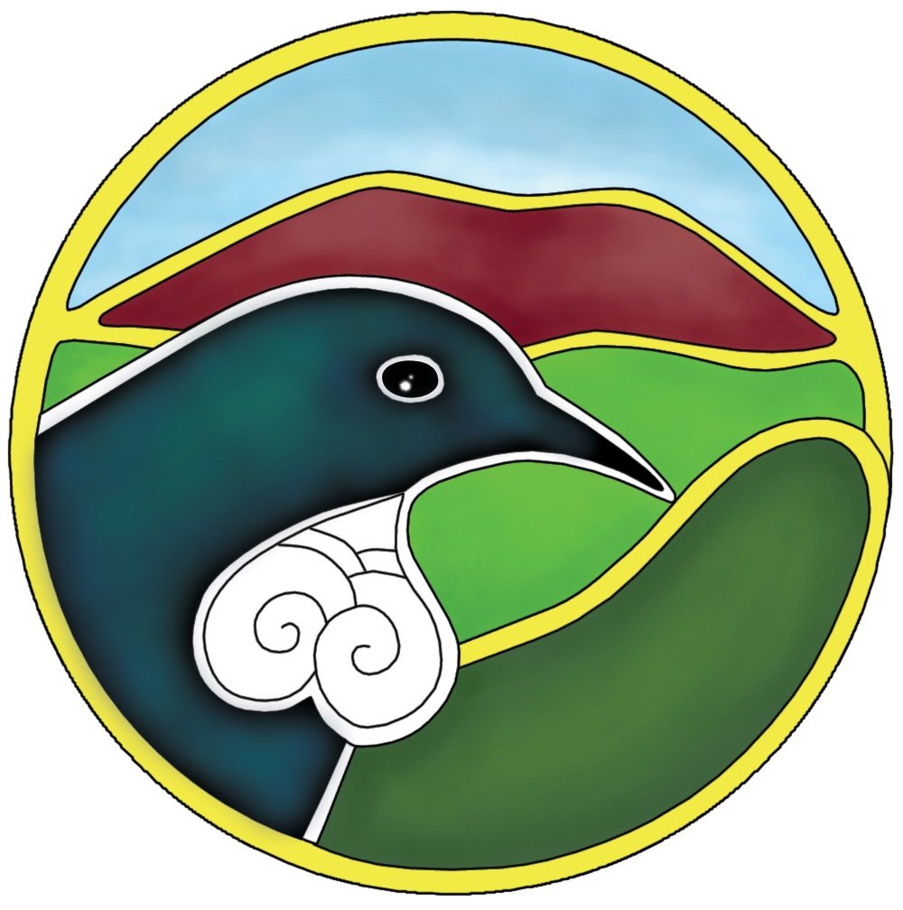
Waikato Biodiversity Forum Newsletter August 2010 Number 28

Kia Ora/Greetings to all Forum Members

Biodiversity Contestable Advice and Condition Funds
The funding round is now closed. It is anticipated that the Funds will be open in September 2010 for applications and www.biodiversity.govt.nz/biofunds
Anyone proposing to submit an application, prior discussion with Fund staff is recommended. So if you have any questions or wish to discuss any aspect of your project or proposed application please feel free to call Katrina or Susie on 0800 86 2020.

How to apply You need to familiarise yourself with the Biodiversity Fund Guides and Exclusions for funding. http://www.biodiversity.govt.nz/land/nzbs/pvtland/conditionapps.html
ONLINE APPLICATIONS: As with previous funding rounds you are encouraged to submit applications online using the appropriate form for the Advice Fund or Condition Fund. www.biodiversity.govt.nz/apply Refer to the online application guide for helpful notes and hints http://www.biodiversity.govt.nz/land/nzbs/pvtland/Guide_4_Electronic_Online_Applications.pdf
MANUAL APPLICATIONS: If you are submitting an application manually applicants must use the appropriate and revised application forms for this round.
http://www.biodiversity.govt.nz/land/nzbs/pvtland/conditionapps.html
I encourage as many private landowners as possible to apply to this fund as there is no guarantee that it will continue after the present money is used up.

Funding Advice
The Forum’s website has a comprehensive list of funders. Moira is available for funding advice.

Plant Conservation Network Awards for 2010
The Network is now calling for nominations for the 2010 Plant Conservation Awards. These awards will be made at the NZPCN Conference in Christchurch at the Conference dinner on Friday 8 October.
Download the nomination form here:
NZPCN Award Nomination form
The award categories are:
- Individual involved in plant conservation
- Plant nursery involved in plant conservation
- School plant conservation project
- Community plant conservation project
- Local authority protecting native plant life
- Young Plant Conservationist of the Year (under 18 years at 30 June 2010)
Please send your nomination form by Wednesday 22 September 2010 to:
New Zealand Plant Conservation Network
P.O. Box 16-102
Wellington, New Zealand
Email: sarah@wildlands.co.nz
www.nzpcn.org.nz

Pukemokemoke Bush Reserve
A fierce 100-horse-power, privet-munching herbivorous T-rex has left its mark on the bush reserve of Pukemokemoke at Tauhei. Owner of T-Rex Vegetation Control, Steve Hyland says, “the T-Rex has a great
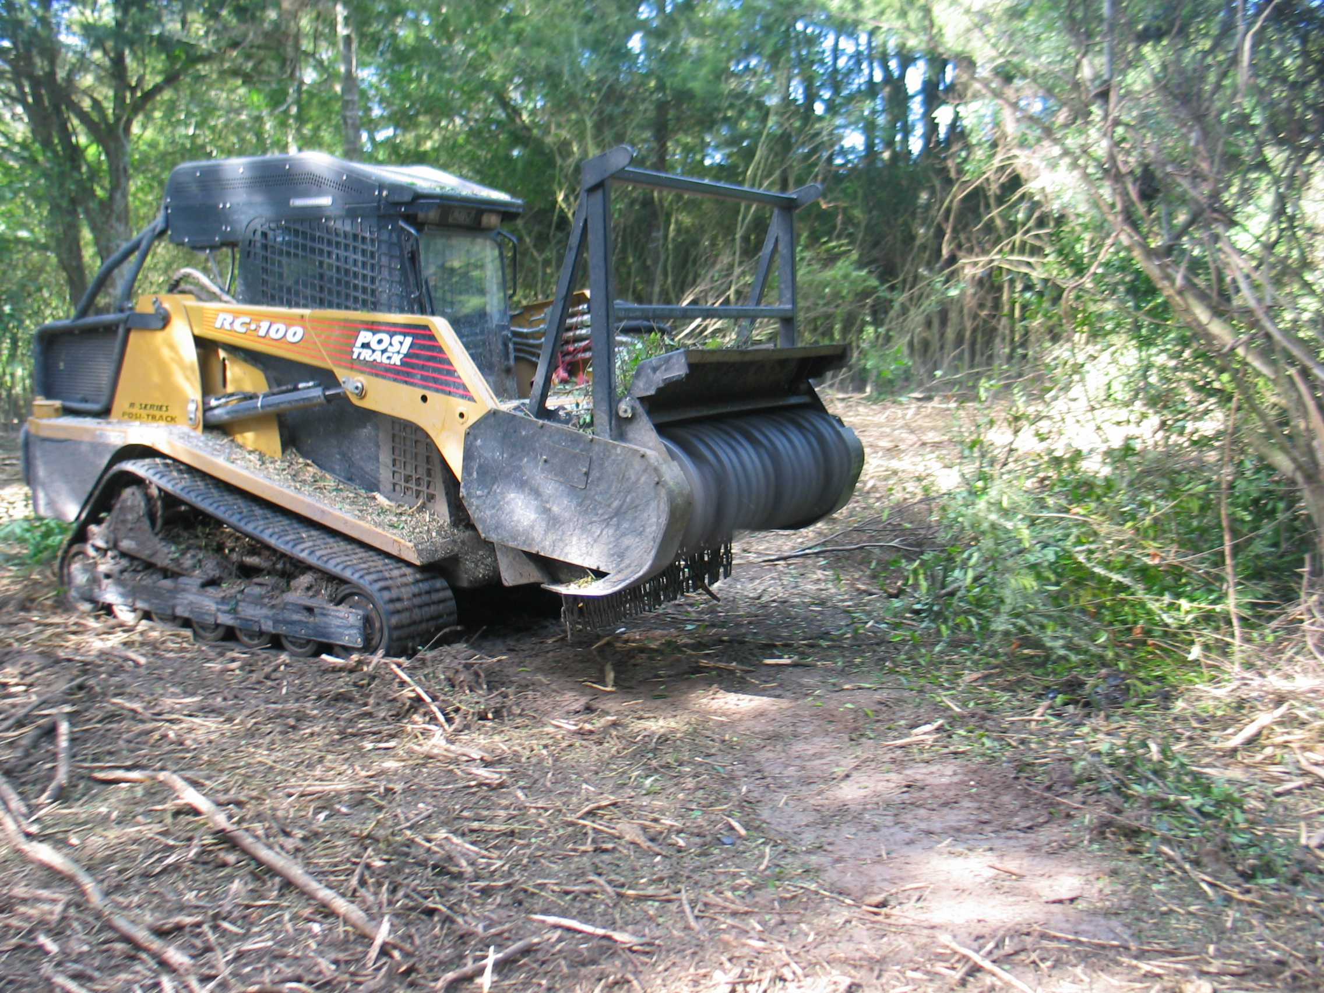
appetite and loves to munch privet, gorse, bamboo and the like.” This powerful machine completed in three days what would have taken a dedicated bunch of volunteers hundreds of hours of tedious work cutting the privet by hand, with loppers or scub-cutter. Its use has brought forward the planting programme along the Mangatea Stream by at least 12 months. Attempts to deal with the infestation of privet in the flood plain area of Pukemokemoke has been almost overwhelming. Its clearing and subsequent revegetation of the area with native species or open grassed picnic spots will greatly enhance the appearance and use of this wonderful forest remnant as a recreational asset in the Waikato. Alan Leadley.

Waikato Community Conservation Fund
Applications close 4.00pm on Monday 20 September 2010 for the Waikato Community Conservation Fund
The Fund will assist community groups to undertake the following projects or activities:
• Protection, enhancement or restoration of native species, habitats, natural
features or historic heritage (e.g. fencing or pest control).
• Improving recreational opportunities to increase public enjoyment of an area.
• Increased public understanding of, and involvement in, conservation through
education, interpretation or public information (e.g. brochures or displays).
• Facilitation or administration costs of establishing a group, governance or training
of members to help achieve conservation outcomes.
Any non-profit community group (existing or proposed) whose purpose is to be involved in a conservation project or activity on public or private land. Funding is restricted to projects that occur or will benefit conservation within the Department of Conservation's Waikato Conservancy boundaries.
The application form and guidelines are attached and are also available from the DOC website at www.doc.govt.nz/waikatocommunityconservationfund
For further information contact Jan Simmons, phone 07 858 1000.

Weedbuster Awards 2010-Congratulations
A big congratulations go to the following Forum members who received weedbuster awards recently. Advocates of the Tongariro River - overall winner of Waikato Region Weedbusters Award for outstanding work this group has done with weeding riparian areas of the Tongariro River.
The Hayes Family- Award for weed work on private land as part of lake protection and restoration at Horsham Downs, near Hamilton.
Wharekawa Catchment Care Group - award for Education for running weed swaps and encouraging weed awareness in their local community near Opoutere on the Coromandel.

Federated Farmers - Sow Seeds for Landowner Support
Federated Farmers is always keen to be involved with measures that protect biodiversity. Remnant bush is often found on farms where either the land has been historically too steep and expensive to clear, or because the land owner has valued having bush on their property. Primary producers are the most affected by biodiversity regulation, as bush is excruciatingly rare on other land uses like urban or industrial. Federated Farmers works hand-in-hand with biodiversity organisations such as the QEII Trust, with Chairman Sir Brian Lochore a Federated Farmers member, and the Landcare Trust where Trustee Bruce McNabb is also a member.

Federated Farmers recognises that councils have obligations under Section 6 of the Resource Management Act to protect areas of significant indigenous vegetation and significant habitats of indigenous fauna. Many councils have carried out this obligation by identifying areas on maps that they deem to be significant, and then label these sites as Significant Natural Areas (SNAs). The South Waikato District Council has indicated that it will be identifying SNAs in its review of the District Plan. Often a mapping exercise of areas is undertaken using aerial photos, however many councils do not have the financial resources to visit and ground-truth all the identified sites. Federated Farmers has major concerns about inappropriate identification of SNAs in district plans. Sometimes mistakes are made during the mapping when exotic forest, gorse or poor quality bush on the aerial photo can be incorrectly identified as significant indigenous vegetation. In situations like this we encourage landowners to invite the council to visit the SNA on the farm so that mistakes can be rectified, the boundary adjusted or even the classification removed.

Non-regulatory methods need to be included in district plans, as these methods tend to forge positive partnerships between land-owners and councils, with biodiversity being the winner. Farmers invest personal time and money to manage their bush as best they can by doing boundary weed control, keeping possum numbers down and fencing out livestock. A kilometre of post-and-wire fencing costs around $9,000, and many farmers are doing this type of work without any help or recognition. At June 2009, Waikato had 16,855ha of land in QEII covenant, which is the most land covenanted by region in the country. This demonstrates the commitment to biodiversity that Waikato landowners have, as they have locked up this land permanently for a public good.
Methods that provide incentives for landowners to protect and actively manage indigenous vegetation on their property can work wonders. It also is important that education and information is available about types of vegetation and habitat, why they are special and how to contact agencies that support landowners. Federated Farmers doesn’t want biodiversity on private property to be viewed as a liability, and so acknowledgement of the private resource that goes into maintaining it is a great start. As the South Waikato District Council reviews the district plan, Federated Farmers will be advocating for fair and sensible outcomes for biodiversity protection that will work for everyone. Rhea Dasent, Regional Policy Advisor for Federated Farmers.

Animal Health Board and Blue Duck Protection
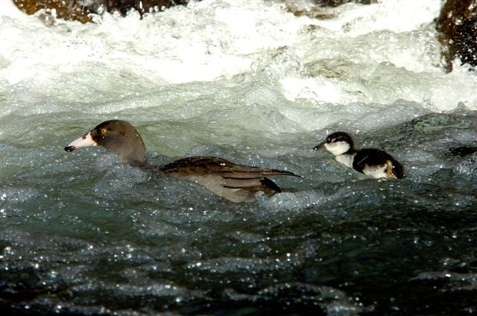
What started out as a discussion around how to encourage iwi buy-in to 1080 operations has begun to produce some positive results. Earlier this year when the East Taupo aerials were being considered in the light of iwi acceptance the observation was made “…it’s a shame there is not biodiversity in the area that can benefit from AHB operations”. It turns out there might be. Discussions with local iwi revealed that the area could have habitat suitable for blue duck relocation and could even still hold some remnant populations. The East Taupo aerials comprise 63,000 ha of which 95% is pine forest with the remainder sparse native habitat primarily along streams. At an AHB hui in May this year the idea of enhancing the blue duck population was accepted by the iwi trust management and beneficiaries. A survey will now be undertaken by a local iwi biodiversity contractor using locals to search out suitable habitat and remaining duck populations. Surveys are currently on hold until trout have finished spawning then they will start around the Waitahanui River before moving onto other possible sites. It is hoped that if blue duck are found and has suitable environment for further enhancement, the iwi, with help from the Lake Taupo Forest Trust and supported by the Animal Health Board, will look for funding to establish an ongoing programme for their protection. . Chris Dawson Community Relations Adviser AHB

AHB and Long Term Bird Monitoring.
The AHB is looking at long term bird monitoring in some areas of its core work. The intent is to show long term effects of 1080 on bird populations in areas treated at least 2 times over a 10 year period. The method being considered is based on 5 minute bird counts used by DOC and others but differs in that it uses digital counting stations (digital sound recorders). These help improve accuracy of the method as the stored data allows analysis of data away from the field and can be cross checked by others, if required. Placement of data stations is on predetermined sites located in the field by GPS and with leaving them there for the required time- usually a few nights. Another area is chosen as a ‘control’ site (i.e. no 1080 control undertaken) to remove any bias from data due to daily weather or extremes of the season. The field side of this activity can be assisted by any volunteers following GPS directions and AHB’s intention is to involve locals in this part of the programme, where at all possible. Reading/ listening to the data requires a more practiced ear and costs and availability of getting this expertise is still being worked out. DOC has been trialing this method and while the jury is still out for DOC it’s first use seems to have achieved the objectives of being a more accurate bird monitoring system. The area being considered for its use by the AHB is the Turangi area and AHB is currently in discussions with Lake Rotoaira Forest Trust regarding how information from this method might benefit ongoing control in the area. . Chris Dawson Community Relations Adviser AHB

Kauri 2000
The Trustees of Kauri 2000 would like to thank all the volunteers who came out and helped plant this year.
Another 2040 kauri were planted at the Matarangi Reserve with the help of students from the Mercury Bay Area School, St. Peter’s School Cambridge, the Coromandel Outdoor Language Centre, our sponsors from the Bank of New Zealand and Richardsons Real Estate and last but definitely not least our wonderful local volunteers who join us every year. Thanks also to the Tairua School students who planted another 100 kauri at Te Karo Bay / Sailors Grave this year. If you or your group would like to come over to the Coromandel next June to help us plant please contact us at info@kauri2000.co.nz with your details. Plant a kauri…recreate a forest!

Environmental Candidates Forum
Monday September 20th, Chartwell Room, Hamilton Gardens. Starting 7pm.
The Environmental forum for candidates standing for Hamilton City Council and the four Hamilton positions on Environment Waikato will follow a similar format to previous years. Questions from environmental groups will be put to the candidates in the weeks leading up to the elections. At the forum each candidate will be given a set amount of time to speak on a topic. Questions will then be directed to candidates from the floor. If you are a member of an environmental community group please send in a question you would like to be put to the candidates for their written response. Include your name and group name and contact details.

Waterways Ecology Team (WET)
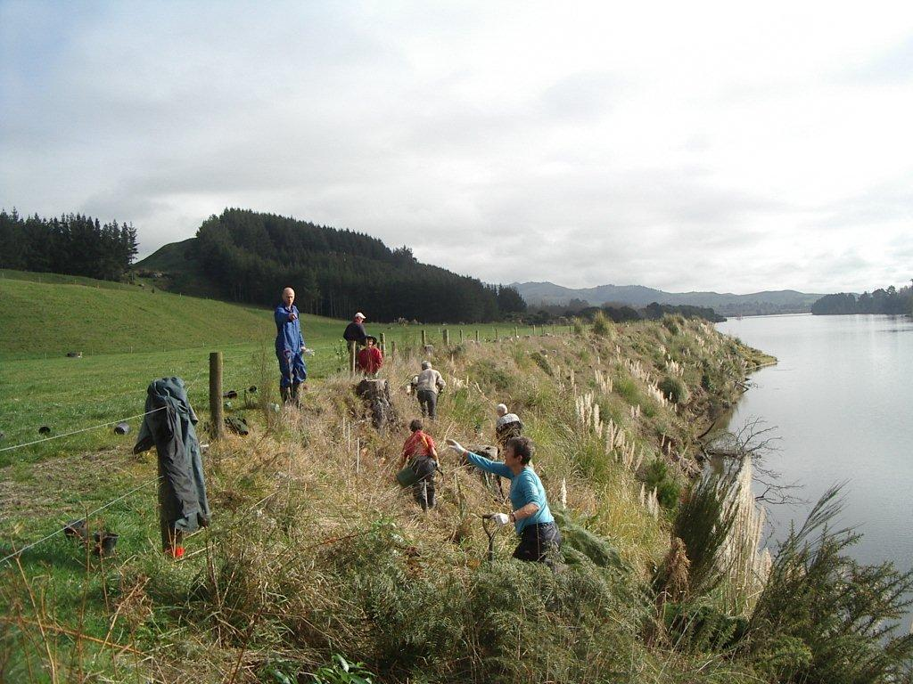Perched on the edge of Lake Karapiro is not for the faint hearted!! The Waterways Ecology Team has just completed a massive task of planting hundreds of native plants into a 1km stretch along the edge of the lake. In places the gradient is 1:2 and steeper, but as usual, we keep going on, in our industrious way! The farmers joined in too and although it was a huge task, we found the two days went very quickly. There will be a few aching bones and muscles at the moment! T he very best part of the plantings were the lunches which were supplied each day for us, by the women of the farm. We were most appreciative of this delicious treat! It was very difficult to go back to digging after that!! But we did! After completing all the plantings, bamboo stakes were placed next to each plant for support and to mark its whereabouts. Carpet squares had been delivered by Van Dyks Flooring Xtra, Putaruru. These were placed around each plant base with the purpose of suppressing weeds. Funding assistance has been sourced from Fonterra for this project. All native plants have been carefully tended by the Maungatautari Nursery Team volunteers. All finances from this project are to be donated to the Maungatautari Ecological Island Trust. The Dairy Farm will eventually have a more picturesque boundary, which can be viewed from State Highway 1. Pat e Williams

South Waikato District Plan Review
Issues Paper 3 is nearly ready to be released for public comment. It is focussed on the District’s Landscapes
and Natural Areas. This paper is a follow on from the Isthmus Landscape Study and the Wildlands work on Significant Natural Areas (SNAs). It looks at some options, and suggests Council’s initial preferred approach
for how landscape and SNAs might be dealt with in the new Plan. For SNAs the continuation of the
present non-regulatory approach is suggested. This means working with landowners instead of listing
areas in the Plan and having a Plan rule that requires land use consent to be obtained before natural areas
are cleared, drained or otherwise modified. Paper 3 will be released for public comment in August.

Hamilton City Council District Plan Review
Biodiversity hits the District Plan spotlight. Hamilton City Council is lifting the lid on its potential solutions to the city’s most significant issues, distributing a summary flyer to all residents and making it available online from 28 August. The flyer, entitled ‘Snapshot’, takes an easy to read look at how the city hopes to address Hamilton’s most pressing issues, and asks residents their opinion about what Council is thinking so far. Snapshot covers a range of issues, including how the city hopes to ensure future development protects Hamilton’s natural character and is in line with the City’s Environmental Sustainability Strategy. Residents are encouraged find out more and tell Council what they think by visiting www.fastforwardhamilton.co.nz or dropping into their local library for a copy of the full report and discussion document - Big Picture. The period for public comments closes on 29 October 2010. Paula Rolfe Project Manager District Plan Review.
Flora of Aotearoa/New Zealand
11-25 February 2011, at the University of Waikato
No prerequisites required, just a keen interest to learn more about plant identification and New Zealand's amazing flora. This popular second year paper is for anyone keen to learn how to identify plants and about the origin's of New Zealand's unique flora. This course provides an introduction to field identification, philosophy and techniques of plant systematics focusing on endemic New Zealand plants. Skills include field identification of plants and knowledge of plant families, genera and species representative of the New Zealand flora. This intensive two week course starts with a field trip to Pureora Forest Park. The next two weeks are spent in lecture, labs, and two more day trips. Students then complete an independent project. This course historically attracts students from a broad range of backgrounds, including university students, professionals wanting to up skill to amateur botanists wanting to learn more, ecologists, ethnobotanists, landscape architects, etc.
Contact Chrissen Gemmill gemmill@waikato.ac.nz for further information.
Conservation Volunteers - Casual Team Leader Position
A position is available with Conservation Volunteers. The Casual Team Leader is responsible for the safety, welfare and supervision of volunteers on practical conservation projects. Please contact Yuki Fukuda, Catchment Care Programme Manager, Hamilton, Office: 7 859 2401, Mobile: 021 755 226
Email: yfukuda@conservationvolunteers.co.nz and see the website www.conservationvolunteers.co.nz

If you want to contact people whose details are not in the newsletter you can go through the Contact Us page on the Forum website and send an email to me. I’ll put you in touch with them.
The newsletters are all placed on www.waikatobiodiversity.org.nz. for easy access.
Cheers Moira

